Principle Component Analysis

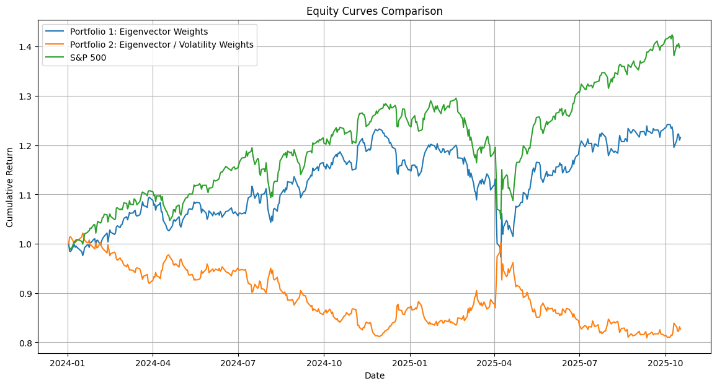

1. Overall Trend & Performance
Portfolio | Description | Performance vs. S&P 500
Portfolio 1 (Blue) | Eigenvector Weights - weighted assets according to the leading eigenvector of the correlation matrix (systematic exposure). | Tracks the S&P 500 moderately well, with lower drawdowns but also smaller total gains. It behaves like a smoothed, lower-beta proxy for the index.
Portfolio 2 (Orange) | Eigenvector / Volatility Weights - eigenvector weights scaled inversely by volatility. | Underperforms heavily. The scaling by volatility likely over-weighted low-volatility stocks, hurting returns when high-beta names rallied. It shows persistent under-performance and limited recovery.
Benchmark (Green) | S&P 500 cumulative return | Up ~40% over the period, your baseline for comparison.

📉 2. Cumulative Return Dynamics
- S&P 500 shows a steady climb with typical cyclical dips.
- Portfolio 1 captures the overall direction of the S&P but with lower amplitude -consistent with principal-component portfolios emphasizing broad market exposure but diluting idiosyncratic risk.
- Portfolio 2 diverges early and stays weak, suggesting that risk-parity-style normalization on PCA weights can over suppress alpha in a market dominated by momentum and sector skew.

⚙️ 3. Volatility & Drawdown Behavior
- The blue line’s smoother path shows reduced volatility - confirming PCA’s risk-compression effect.
- Around early 2025, both PCA portfolios show a sharp dip while the S&P rebounds faster - possibly due to eigenvector instability during regime change (covariance matrix shifted).
- The orange line’s extreme sensitivity suggests it may be over-regularized or dominated by small-cap/defensive sectors that lagged the market recovery.

